DevOps Lab Program 1
Project Structure:
Program-1/
Dockerfile
requirements.txt
app.py

Steps for execution:
Step 1: Create a Dockerfile
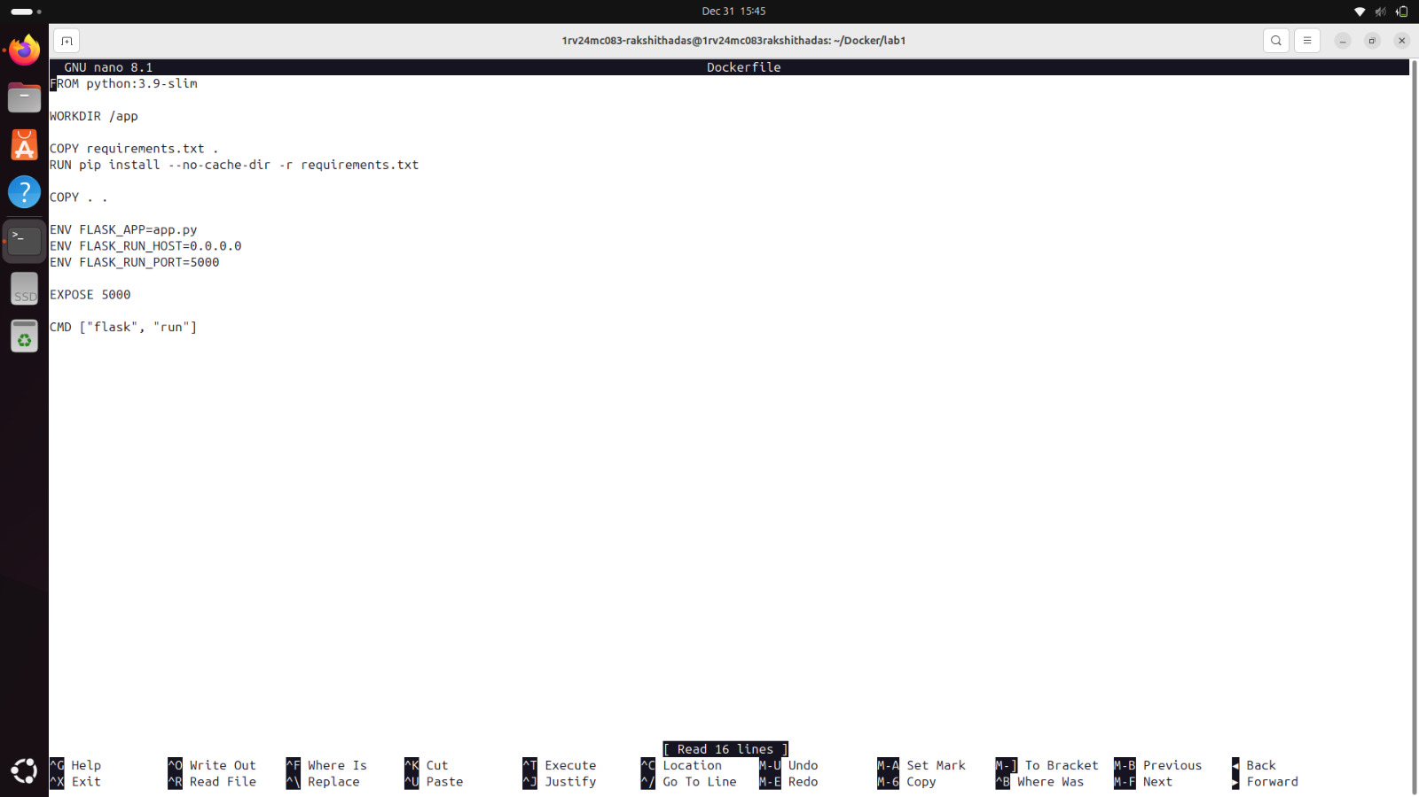
Step 2: Create a python file called app.py
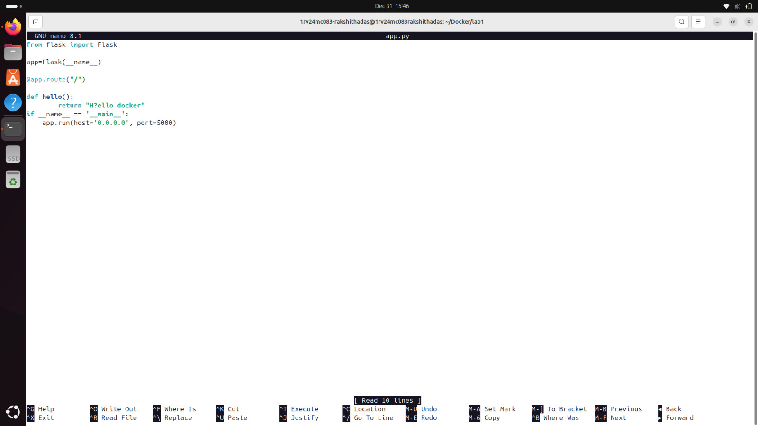
Step 3: Create a file called requirements.txt with following content
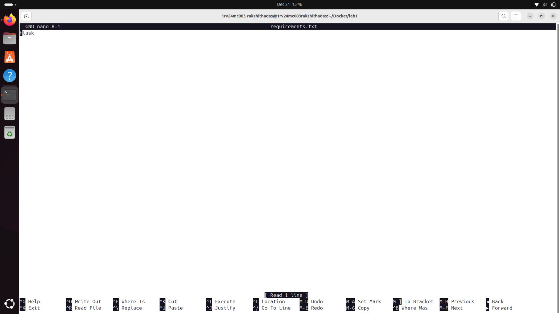
Step 4: Execute the docker build command on the terminal. Verify that the image is present once it has been built
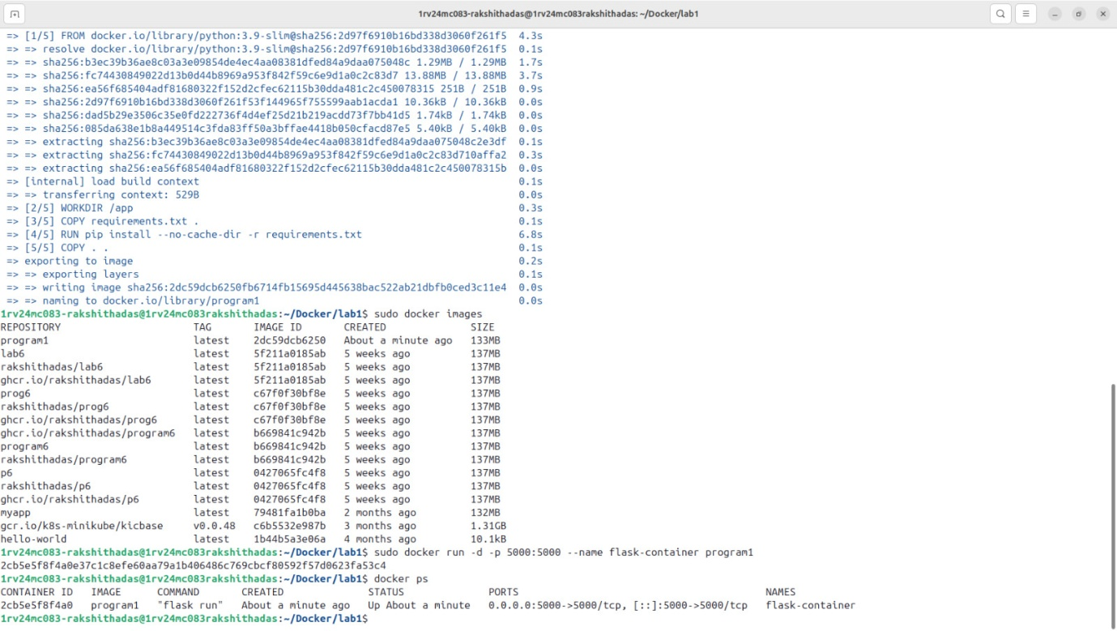
Step 5 : Run the Docker Run command specifying the port number and give a name for the container
Step 6: Test the container by verifying the localhost details on the web browser. The text “Hi from Docker” will be displayed.
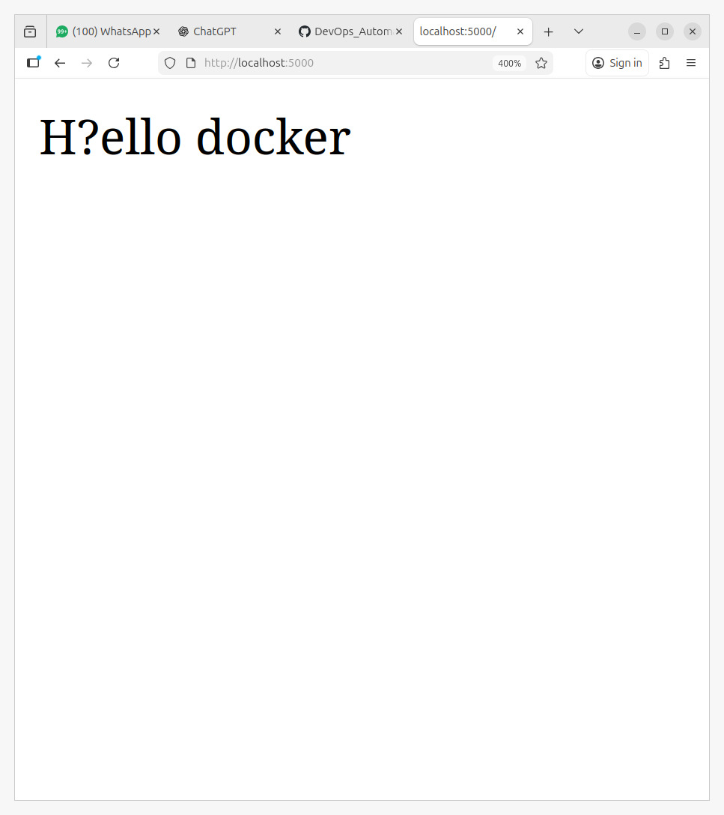
Step 7: Stop the container using its container name
Step 8: Remove the container using the container name
Step 9: Delete the docker image using its name

